- \Operation\Carton ejection\Carton ejection
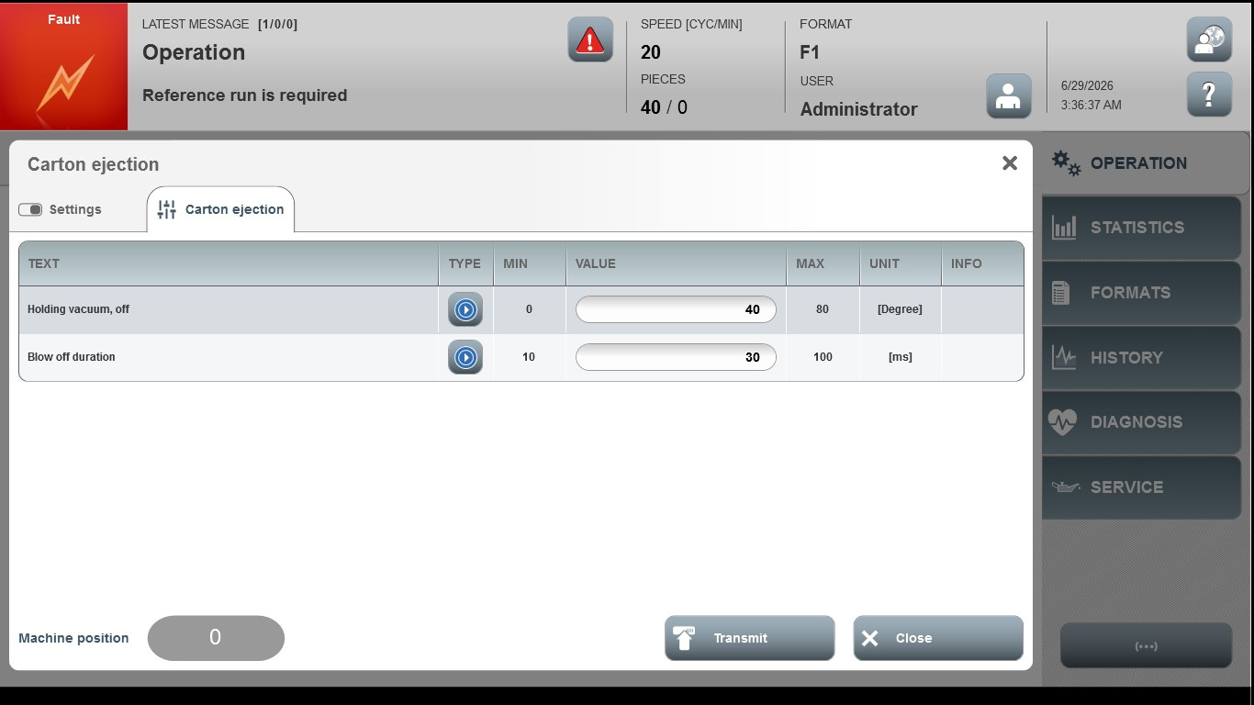
Acceptance criterion | Limits | Pass / Fail: Dev-No. | Date | Initials
Screen matches screenshot | N / A
Holding vacuum, off | 0 … 80
Blow off duration | 10 … 100

